|  |  |  |
| --- | --- | --- |
| **Report IDM reference No.** | *EFDA_D_2CXDHG* | **Version: see IDM** |

DRAFT

on Deliverable

*MAT-1.3.3-T2-D1 Report on Interim DEMO Design Criteria Guidance (CCFE)*

|  |  |  |  |
| --- | --- | --- | --- |
|  | | **Deliverable-ID**[1] | MAT-1.3.3-T2-D1 |
| **Work Package** | *WPMAT* | **Date** | *31 Dec 2015* |
| **Project Leader** | *Manminder Singh Kalsey* | | |
|  | | | |
| **TS Title** | *DDC – DEMO Design Criteria* | | |
| **TS Ref. No.** | *EDDI-1.3.3* | **TS IDM-link** | [*2M9TH3*](https://idm.euro-fusion.org/?uid=2M9TH3&action=get_document) |
| **Task Owner** | *Manminder Kalsey* | | |
| **RU(s)** | CCFE | | |

|  |  |
| --- | --- |
| **Report Review & Approval** | |
| **IDM role** | **Name(s)** |
| **Author** | *Manminder Singh Kalsey* |
| **Co-author(s)** |  |
| **Reviewer(s)** | *Mike Fursdon, Mike Gorley* |
| **PMU Reviewer** |  |
| **Approver** |  |

|  |  |  |  |  |  |
| --- | --- | --- | --- | --- | --- |
| X | Study / Assessment |  | Procurement / Commissioning of Hardware |  | Industry |

|  |  |  |  |
| --- | --- | --- | --- |
|  | Use of Facility |  | Other *{please specify}* |

|  |
| --- |
| **Executive Summary** |
| **This is the DRAFT DEMO Design Criteria. It is a work in progress, and as such shall be updated regularly. It is intended to be written in the format that would be released once it is fully populated and reviewed. Notes are written in red as additional guidance and explanation in the absence of the released DDC. The red notes shall be removed once the DDC Issue 1 is released.**  **This DRAFT has not been reviewed and as such shall not be taken in precedent over established Codes and Standards.**  **The first issue of the DDC is planned for December 2016.** |

|  |
| --- |
| **Comments** (shortcomings, deviations, etc.) |
| *if any please shortly indicate here* |

**Table of Contents**

1 General Information 7

1.1 Introduction 7

1.2 Included Components 7

1.2.1 Divertor 7

1.2.2 Blanket 8

2 Definitions and Abbreviations 9

2.1 Definitions 9

2.2 Abbreviations 10

3 Loading and Stress Classifications 11

3.1 Load Classifications 11

3.1.1 Primary Loading 11

3.1.2 Secondary Loading 11

3.2 Load Types (For future “Partial Factors” design assessment) 12

3.3 Stress Classifications 12

3.3.1 Primary Stress 12

3.3.2 Secondary Stress 12

3.3.3 Residual Stress 12

4 Operating Conditions 13

5 Damage Mechanisms 14

5.1 Excessive deformation 14

5.1.1 Description of Damage 14

5.1.2 Affected Materials 14

5.1.3 Critical Factors 14

5.1.4 Appearance or Morphology of Damage 14

5.2 Plastic Collapse 14

5.2.1 Description of Damage 14

5.2.2 Affected Materials 14

5.2.3 Critical Factors 14

5.2.4 Appearance or Morphology of Damage 14

5.3 Exhaustion of Ductility 15

5.3.1 Description of Damage 15

5.3.2 Affected Materials 15

5.3.3 Critical Factors 15

5.3.4 Appearance or Morphology of Damage 15

5.4 Fast Fracture 15

5.4.1 Description of Damage 15

5.4.2 Affected Materials 15

5.4.3 Critical Factors 15

5.4.4 Appearance or Morphology of Damage 15

5.5 Brittle Fracture 15

5.5.1 Description of Damage 15

5.5.2 Affected Materials 15

5.5.3 Critical Factors 15

5.5.4 Appearance or Morphology of Damage 16

5.6 Ratcheting 16

5.6.1 Description of Damage 16

5.6.2 Affected Materials 16

5.6.3 Critical Factors 16

5.6.4 Appearance or Morphology of Damage 16

5.7 Mechanical Fatigue 16

5.7.1 Description of Damage 16

5.7.2 Affected Materials 16

5.7.3 Critical Factors 16

5.7.4 Appearance or Morphology of Damage 16

5.8 Thermal Fatigue 16

5.8.1 Description of Damage 16

5.8.2 Affected Materials 16

5.8.3 Critical Factors 17

5.8.4 Appearance or Morphology of Damage 17

5.9 Creep 17

5.9.1 Description of Damage 17

5.9.2 Affected Materials 17

5.9.3 Critical Factors 17

5.9.4 Appearance or Morphology of Damage 17

5.10 Creep Fatigue 17

5.10.1 Description of Damage 17

5.10.2 Affected Materials 17

5.10.3 Critical Factors 17

5.10.4 Appearance or Morphology of Damage 18

5.11 Swelling 18

5.11.1 Description of Damage 18

5.11.2 Affected Materials 18

5.11.3 Critical Factors 18

5.11.4 Appearance or Morphology of Damage 18

5.12 Plasma Erosion 18

5.12.1 Description of Damage 18

5.12.2 Affected Materials 18

5.12.3 Critical Factors 18

5.12.4 Appearance or Morphology of Damage 18

5.13 Coolant Erosion 18

5.13.1 Description of Damage 18

5.13.2 Affected Materials 18

5.13.3 Critical Factors 18

5.13.4 Appearance or Morphology of Damage 18

6 Design Assessment Philosophy 18

6.1 Component Functional Elements 18

6.1.1 Structural Element 18

6.1.2 Armour Element 19

6.1.3 Joint Element 19

6.2 Design Life Target 19

6.3 Design Assessment 20

7 Structural Design Assessment 21

7.1 Associated Damage Mechanisms 21

8 Armour Design Assessment 21

9 Joint Design Assessment 21

10 Design Allowable 21

10.1 CuCrZr 22

10.1.1 Physical Properties 22

10.1.2 Analysis Data 22

10.2 Eurofer 22

10.2.1 Physical Properties 22

10.2.2 Analysis Data 22

10.3 Tungsten 22

10.3.1 Physical Properties 22

10.3.2 Analysis Data 22

10.4 Stainless Steel 316LN 23

10.4.1 Physical Properties 23

10.4.2 Analysis Data 23

11 Case Studies 23

11.1 Divertor 23

11.2 Blanket 23

**References**

# General Information

## Introduction

The DEMO Design Criteria (DDC) provides rules for the assessment of Plasma Facing Components (PFC’s) for DEMO.

This Design Criteria comprises the following Sections:

1. General Information
2. Definitions and Abbreviations
3. Loading and Stress Classifications
4. Damage Mechanisms
5. Design Assessment Philosophy
6. Structural Design Assessment
7. Armour Design Assessment
8. Joint Design Assessment
9. Design Allowables
10. Case Studies

## Included Components

The DDC currently covers the following key Plasma Facing Components (PFC). The main reason for focusing on these PFC’s it is these components that will need to operate in a unique and challenging environment. This unique environment is not fully covered by existing design CODES, and hence the need for the DDC was established.

*Note: All other DEMO components should be validated by using appropriate established CODES (ie AFCEN or ASME).*

It must be noted that although this design criteria is intended to cover the listed components (below), it is important that the criteria does not confine the design process to specific geometries and materials. Hence this criteria does not refer to components directly but breaks down components into functional the following functional elements:

* Structural
* Armour
* Joints

More details of these functional elements can be found in 6.1.

### Divertor

The Divertor is a plasma facing component that is positioned inside the Vacuum Vessel. The primary functions of the Divertor are:

* Define the boundary of the plasma
* Enable the control of impurities
* Provide a means for non radiant power fraction exhaust
* Provide a means for helium ash exhaust
* Protect the vacuum vessel by absorbing neutrons

In order to deliver the required functionality, the Divertor will sustain the following environmental effects and loading:

* High heat flux
* Plasma induced surface erosion
* Neutron induced irradiation

### Blanket

The Blanket is a plasma-facing component that lines the majority of the vacuum vessel. The primary function of the blanket is to extract the energy released from a fusion reaction. This is executed through absorbing fusion neutrons into a fluid medium and then using this absorbed energy to generate electricity. In addition the blanket provides the following functionality:

* Generate (breed) tritium by reaction of the fusion neutrons with lithium.
* Act as a neutron multiplier, compensating for neutron loss and thus sustaining the fusion reactions.
* Protect the vacuum vessel by absorbing fusion bi-product neutrons and also the VV from plasma heat, plasma particle.

In order to deliver the required functionality, the Blanket must sustain the following environmental effects and loading:

* High heat flux
* Plasma induced surface erosion
* Neutron induced irradiation

# Definitions and Abbreviations

## Definitions

In order to remove ambiguity from the assessment of DEMO components, the following definitions will apply. Effort has been made to ensure that these definitions have a precision of meaning that is both easily understood and are unambiguous.

Allowable Stress Design (ASD)

Damage

The reduction in component life.

Damage Mechanism

The mechanism that results in damaging the component.

Design Criteria

Detrimental Deformations

Deformations, either elastic or inelastic, resulting from the application of loads and temperatures which prevent any portion of the component structure from performing its intended fuction.

Fail Safe

The design philosophy under which the failure of any single structural component will not endanger lives or property when it fails.

Failure

When a component is no longer able to sustain its required design loads it is deemed to be classed as a failure.

Failure Mechanism

The mechanism that results in a component failure.

Limit State Design (LSD)

Design assessment method where the structure is designed to withstand safely all loads likely to act on it throughout its life. This design philosophy employs the use of Partial Factors.

Load and Resistance Factor Design (LRFD)

### 

Safe Life

The design philosophy under which crack propagation to failure will not occur in the expected operating environments during the specified service life of the reactor; also the period of time for which the integrity of the structure can be ensured in the expected operating environments.

Structure

All components and assemblies designed to sustain loads or pressures, provide stiffness and stabililty, or provide support of containment.

System

A major combination of components and assemblies that functions as a unit.

Fail Safe

A design philosophy under which the failure of any single structural component will not degrade the strength or stiffness of the remainder of the structure to the extent that it cannot complete the remainder of the pulse.

## Abbreviations

|  |  |
| --- | --- |
|  |  |
| *DDC*  *PFC* | *DEMO Design Criteria*  *Plasma Facing Components* |
| *ALM* | *Additive Layer Manufacturing* |
| *ASME* | *American Society of Mechanical Engineers* |
| *ASSY* | *Assembly* |
| *ASTM* | *American Society for the Testing of Materials* |
| *BPVC* | *Boiler and Pressure Vessel Code (an ASME design code)* |
| *CCFE* | *Culham Centre for Fusion Energy, Great Britain (formerly UKAEA)* |
| *EB* | *Electron Beam* |
| *ELI* | *Extra Low Interstitial* |
| *Eqpt* | *Equipment* |
| *GMAW* | *Gas Metal Arc Welding* |
| *HAZ* | *Heat Affected Zone* |
| *HCPB* | *Helium Concept* |
| *HIP* | *Hot Isostatic Pressing (a type of joining process)* |
| *HVOF* | *High Velocity Oxy-Fuel Spraying* |
| *MAG* | *Metal Active Gas (a type of welding process)* |
| *NADCAP* | *National Aerospace & Defence Contractors Accreditation Programme* |
| *NDT* | *Non-Destructive Testing* |
| *PBF* | *Powder Bed Fusion (a type of additive manufacturing process)* |
| *PECS* | *Pulsed electric Current Sintering (a type of joining process)* |
| *PPS* | *Pre-Production Samples* |
| *R&D* | *Research and Development* |
| *S/Steel* | *Stainless Steel* |
| *TIG* | *Tungsten Inert Gas (a type of welding process)* |
| *TSC* | *Thermal Spray Coating* |
| *WPBB* | *Work Package Breeder Blanket* |
| *WPS* | *Welding Procedure Specification* |

# Loading and Stress Classifications

## Load Classifications

The loading seen on a Fusion component is complex and generally consists of multiple loads being applied at the same time (load combinations). The application of a single load is rarely seen, however for the purpose of a structural integrity assessment the classification of singular loads into Primary and Secondary Loads is needed.

### Primary Loading

Primary loading is an imposed loading that is necessary to satisfy the laws of equilibrium of external and internal forces and moments. The basic characteristic of a primary load is that in the case of high (non admissible) increment of external loads, it is not self-limiting. As plasticity develops, a stage is reached where no further beneficial redistribution of stress can take place.

The following are examples of Primary loads seen in a Fusion reactor:

* Gravity
* Coolant pressure
* Vacuum
* Seismic
* Electro-magnetic

### Secondary Loading

Secondary loading is a self-balancing loading that results in an unrestrainable deformation in a structure. The basic characteristic of secondary loading is that it is self-limiting, i.e. local flow deformation leads to a limitation of the associated stress.

The following are examples of Secondary loads seen in a Fusion reactor:

* Heat Flux
* Coolant Heat Transfer
* Swelling
* Baking

## Load Types (For future “Partial Factors” design assessment)

Due to differing levels of statistical reliability of loading data, it will eventually be necessary to provide a further level of load definitions (beyond primary and secondary loading). This additional distinguish shall provide an opportunity to apply lower factors of safety to loadings of high certainty. For example, gravity would only require a small FOS (if any) as it has a high level of certainty, however in contrast Seismic loading would require a larger FOS due to its low level of certainty. This shall be detailed further if the DDC adopts the Partial Factor Design assessment philosophy.

## Stress Classifications

The stresses induced in a structure are a result of the load combinations applied. Definitions are provided below.

### Primary Stress

Primary stress is the stress that in induced in the structure as a result of the applied primary loads.

### Secondary Stress

### Residual Stress

# Operating Conditions

During operation, DEMO components shall be subjected to various operating conditions that are made up of load combinations. These operating conditions shall be classified into categories based on both the probability of occurrence and consequences of failure.

The Operating Condition categories have a direct link to the safety factors applied in the structural design assessment. These safety factors have a critical role to play, and if inappropriate can result in either excessive or under conservatism, neither of which are desirable when assessing the validity of DEMO designs. Therefore the process of determining Operating Condition Categories is under review.

*Note: Note, it has been recommended that a full review of component classifications and their relation to the DDC design classifications should be carried out. It has been noted that DEMO SIC classifications have been proposed, it is likely that the PFC’s could contain multiple SIC classifications, how this shall be handled from a design criteria prospective needs to be clearly defined. In addition, other classifications need to be taken into consideration (ie Remote Handling, Vacuum, Quality) together with the required level of availability (investment protection).*

*In the absence of further guidance it is recommended to follow the recommended design Code (RCC-MRx or SDC-IC).*

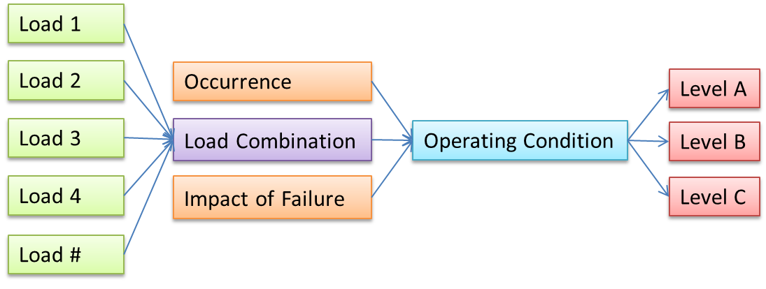

# Damage Mechanisms

The key damage mechanisms relevant to PMC’s are defined in this section. Only damage mechanisms are listed here, however all of these damage mechanisms have the potential to cause failure and hence if left unresolved can also become failure mechanisms.

Most of the damage mechanisms listed would evolve quite quickly into a failure mechanism and hence it is very difficult to build into the design a degree of damage tolerance. However, some of the more complex damage mechanisms (Fatigue, Creep & Swelling) have the potential of having an appreciable period before causing a failure, hence this damage could be tolerated for a period of time. The design assessment found in Section 6 shall assess the ability of designs to withstand these damage mechanisms during the planned component life.

*Note: This section intends to provide a clear unambiguous description of the applicable damage mechanisms. It is also intended that physical examples are provided preferably from the Fusion industry. This shall provide the DEMO designer with a greater understanding of the type of damage mechanisms we are intending to design against.*

## Excessive deformation

### Description of Damage

Deformations, either elastic or inelastic, resulting from the application of loads, temperatures and environmental conditions which prevent any portion of the structure from performing its intended function.

### Affected Materials

### Critical Factors

### Appearance or Morphology of Damage

## Plastic Collapse

### Description of Damage

### Affected Materials

### Critical Factors

### Appearance or Morphology of Damage

## Exhaustion of Ductility

### Description of Damage

### Affected Materials

### Critical Factors

### Appearance or Morphology of Damage

## Fast Fracture

### Description of Damage

### Affected Materials

### Critical Factors

### Appearance or Morphology of Damage

## Brittle Fracture

### Description of Damage

Brittle fracture is the sudden rapid fracture under stress (residual or applied) where the material exhibits little or no evidence of ductility or plastic deformation.

### Affected Materials

* Tungsten
* Eurofer
* CuCrZr

### Critical Factors

* For a material containing a flaw, brittle fracture can occur. Following are three important factors.
  + The Material fracture toughness (resistance to crack like flaws) as measured in a Charpy impact test.
  + The size, shape and stress concentration effect of a flaw.
  + The amount of residual and applied stress on the flaw.
* Susceptibility to brittle fracture may be increased by the presence of embrittling phases.
* Cleanliness and grain size have a significant influence on toughness and resistance to brittle fracture.
* Thicker material sections also have a lower resistance to brittle fracture due to higher constraint which increases triaxial stresses at the crack tip.
* In most cases, brittle fracture occurs only at temperatures below the ductile to brittle transition temperature, the point at which the toughness of the material drops off sharply.

### Appearance or Morphology of Damage

* Cracks will typically be straight, non-branching, and largely devoid of any associated plastic deformation (although fine shear lips may be found along the free edge of the fracture, or localised necking around the crack).
* Microscopically, the fracture surface will be composed largely of cleavage, with limited intergranular cracking and very little microvoid coalescence.

## Ratcheting

### Description of Damage

### Affected Materials

### Critical Factors

### Appearance or Morphology of Damage

## Mechanical Fatigue

### Description of Damage

### Affected Materials

### Critical Factors

### Appearance or Morphology of Damage

## Thermal Fatigue

### Description of Damage

Thermal fatigue is the result of cyclic stresses caused by variations in temperature. Damage is in the form of cracking that may occur anywhere in a metallic component where relative movement or differential expansion is constrained, particularly under repeated thermal cycling.

### Affected Materials

All

### Critical Factors

* The number of cycles to failure of a function of stress range, magnitude and temperature.
* The startup and shutdown of equipment increase the susceptibility to thermal fatigue.
* Damage is increased by rapid changes in surface temperature that result in a thermal gradient through the thickness or along the length of a component.

### Appearance or Morphology of Damage

* Cracks usually initiate on the surface of the component.
* Thermal fatigue cracks propagate transverse to the stress and they are usually dagger-shaped, transgranular, and oxide filled. However, cracking may be axial or circumferential, or both, at the same location.

## Creep

### Description of Damage

At high temperatures, metal components can slowly and continuously deform under load below the yield stress. This time dependent deformation of stressed components is known as creep. This deformation can eventually lead to damage that may eventually lead to a rupture.

### Affected Materials

* CuCrZr
* Eurofer

### Critical Factors

* The rate of creep deformation is a function of the material, load and temperature. The rate of damage (strain rate) is sensitive to both load and temperature. Generally, an increase of abot 12°C or an increase of 15% on stress can cut the remaining life in half or more, depending on the alloy.
* The level of creep damage is a function of the material and the coincident temperature/stress level at which creep deformation occurs.
* Below a certain material dependent temperature, creep is not a concern.

### Appearance or Morphology of Damage

* The initial stages of creep damage can only be identified by scanning electron microscope metallography. Creep voids typically show up at the grain boundaries and in later stages form fissures and then cracks.
* At temperatures well above the threshold limits, noticeable deformation may be observed.

## Creep Fatigue

### Description of Damage

### Affected Materials

### Critical Factors

### Appearance or Morphology of Damage

## Swelling

### Description of Damage

### Affected Materials

### Critical Factors

### Appearance or Morphology of Damage

## Plasma Erosion

### Description of Damage

### Affected Materials

### Critical Factors

### Appearance or Morphology of Damage

## Coolant Erosion

### Description of Damage

### Affected Materials

### Critical Factors

### Appearance or Morphology of Damage

# Design Assessment Philosophy

## Component Functional Elements

### Structural Element

The structural element is the backbone of the component primarily providing structural strength. In the case of the PFC’s it is likely that the structural element shall also retain the flow and pressure of a cooling fluid.

### Armour Element

The armour element plates the structural element as is the plasma facing aspect of a PFC. This element is subject to high heat fluxes and plasma erosion.

### Joint Element

## Design Life Target

Traditionally four different design life philosophies are applied in the design of safety critical components in the engineering industry. These philosophies are known as:

* Infinite-Life
* Safe-Life
* Damage Tolerant
* Fail-Safe

The fusion industry has tended to adopt the Safe-Life Design philosophy where components are designed to survive the expected loading without seeing any appreciable damage initiation (failure is assumed when damage is first formed). Although this conservative approach is acceptable in most cases, the DEMO PFC’s operate in a very challenging environment where designing to a Safe-Life Design Philosophy may not be possible. For this reason the DDC utilises a combination of Safe-Life, Damage Tolerant and Fail-Safe Philosophies detailed below and in Figure 1.

* Structural Element, Safe-Life and if required Damage Tolerance.
* Armour Element, Safe-Life and if required Damage Tolerance shall be utilised. However, if required Fail-Safe philosophy is acceptable where if the failure of the Armour must not result in the failure of the structure.
* Joint Element, Safe Life.

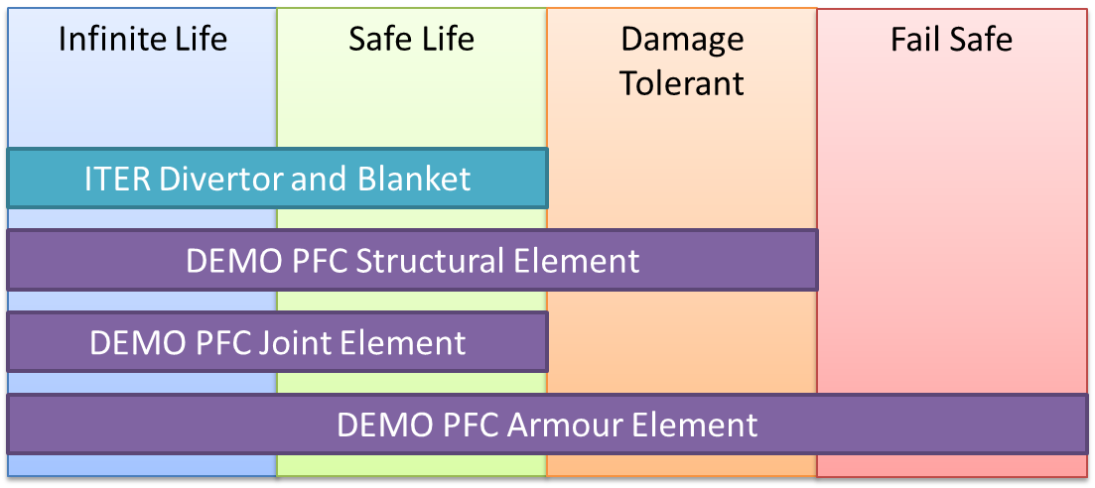

Figure 1: Design Life Target

## Design Assessment

The design assessment process is primarily intended to demonstrate that the proposed design will not fail during the target design life. This is done by predicting the response of a design to the expected loading, and determining if this response would result in causing a failure.

There are a number of numerical methods that can be used in this assessment process, details of which can be seen in Figure 1. Traditionally, the Nuclear Fission industry has utilised the deterministic allowable stress approach as the main method to assess safety critical components. Likewise, the Nuclear Fusion industry has moved in the same direction. In addition to the well established allowable stress approach, the plastic design approach is also occasionally used, however this is often seen as an inaccessible route due to the complexity and the lack of clear guidance on how to use this route to assess components.

Historically, the allowable stress route found in Nuclear CODES have been developed from the pressure vessel industry and are appropriate for simple cases like cylindrical shells under axisymmetric quasi-static loads. However, these rules are not relevant to complex 3D studies. In the Fusion industry, in particular with the PFC’s, using the traditional Nuclear allowable stress rules can be unnecessarily conservative and difficult to apply, in particular the application of stress linearization is time consuming and not relevant.

In the near term, the DDC shall utilise Plastic Design route as this is seen to be more appropriate to PFC geometry than the Allowable Stress Design route.

In longer term, the possibility of utilising the more advanced Partial Factor Design route shall explored, and if deemed to be relevant and beneficial shall be adopted.

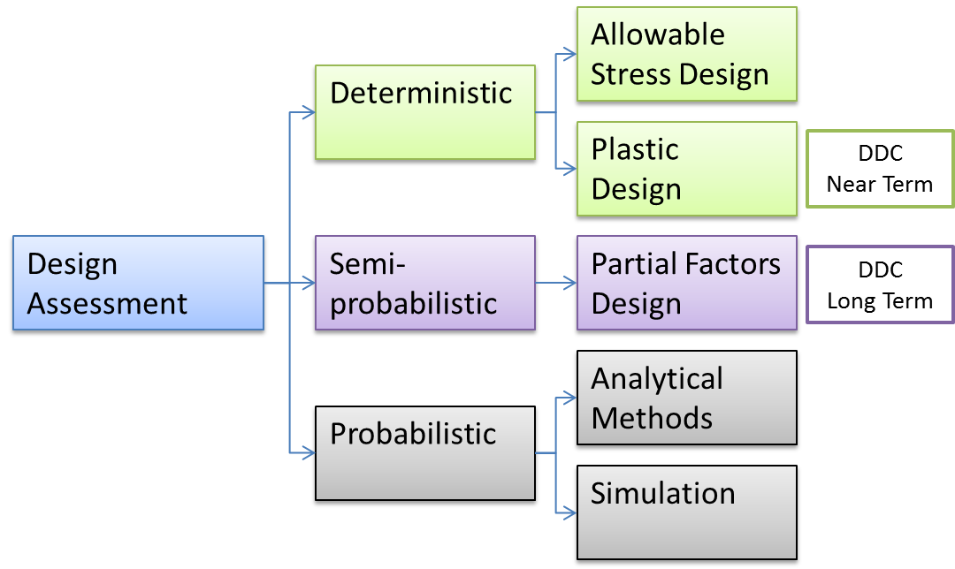

Figure 2: Design Assessment Techniques

# Structural Design Assessment

*Note: It is recognised that both Divertor and Blanket designers are developing conceptual designs that need to be assessed to determine if the desired level of structural integrity is achieved. Until the DDC is approved and released it is recommended that the ITER SDC-IC or the RCC-MRx should be used as these are deemed to be the most appropriate for DEMO PFC’s.*

*Note: The DDC shall provide Plastic Design Rules for all of the identified damage mechanisms.*

*In the cases where the rules in the available C&S are deemed to be sufficient and easy to follow, a reference shall be provided (the DDC shall not cut and paste work that exists elsewhere).*

*In the cases where the rules in the available C&S are deemed to be sufficient but are not easy to follow or are open to interpretation. The DDC shall attempt to re-write the rules in a clear and unambiguous way.*

*In the case where new rules are required. The DDC shall attempt to convey the new rules in a clear and unambiguous manner.*

## Associated Damage Mechanisms

The damage mechanisms associated to each of the PFC’s functional elements are summarised in table???

# Armour Design Assessment

# Joint Design Assessment

# Design Allowable

Complied in this section is all of the material data required to assess the structural integrity of a DEMO PFC’s.

*Note: Although it is intended that the DDC contains all of the material data that a DEMO designer will require. Currently, not all of the data is available and as such there will be gaps in the data. However a programme of work is being carried out in the MAT project to fill these gaps. With regards to irradiated data, the gaps are significant and we are a long way off filling these gaps due to the high level of irradiation seen in DEMO and the high costs and time involved in gaining this data. However, on occasions, it is at this irradiated state that a component is likely to fail, and hence should be assessed. The DDC shall* ***attempt*** *to provide estimated irradiated data to cover the gap in the near term, and a package of work shall be carried out in 2016 to cover this (subject to approval).*

## CuCrZr

### Physical Properties

#### Un-irradiated

#### Irradiated 5dpa

#### Irradiated 10dpa

### Analysis Data

#### Un-irradiated

#### Irradiated 5dpa

#### Irradiated 10dpa

## Eurofer

### Physical Properties

#### Un-irradiated

#### Irradiated 5dpa

#### Irradiated 10dpa

### Analysis Data

#### Un-irradiated

#### Irradiated 5dpa

#### Irradiated 10dpa

## Tungsten

### Physical Properties

#### Un-irradiated

#### Irradiated 5dpa

#### Irradiated 10dpa

### Analysis Data

#### Un-irradiated

#### Irradiated 5dpa

#### Irradiated 10dpa

## Stainless Steel 316LN

### Physical Properties

#### Un-irradiated

#### Irradiated 5dpa

#### Irradiated 10dpa

### Analysis Data

#### Un-irradiated

#### Irradiated 5dpa

#### Irradiated 10dpa

# Case Studies

## Divertor

## Blanket

1. One *Deliverable Report* shall be submitted for each deliverable e.g. Study Report, Commissioning Report, Final Assessment Report, Technical Acceptance Report, Procurement Report, etc.